A novel Remote Health Monitoring and Analyzing System using IoT

Anuska Sil , Saurav Pati ,Suchita Ghosg,Itika Sarkar, Swarup Kumar Mitra
MCKV Institute of Engineering, Department of ECE, Howrah, WestBengal, India
anuskasil@gmail.com, pati.saurav629@gmail.com,suchita2699@gmail.com, itikaitzme@gmail.com,swarup.mitra@mckvie.edu.in

Abstract—With the doctor to patient ratio of 0.7 per 1000 people in India remote health care, is an utmost need. This device aims to make easily accessible free healthcare at remote access. In the free version of the healthcare application real time health details of the user is provided. The paid version of the healthcare application consists of a professionally analyzed report from a medical practitioner. Furthermore the application gives personalized daily goals and reminders to the user for facilitating easy healthcare. The sensed data of one's heart rate, oxygen saturation level, temperature and pressure is interfaced with node microcontroller unit (MCU). Our work interfaces the health data through IOT and mobile application from patient to doctor. The gathered data is processed by think speak , firebase integration and MATLAB software for communicating over APP interface. The novel application software displays the real-time data from patient to the doctor.
Keywords—healthcare, MCU, IOT, think speak, firebase integration.

Introduction
Demand of doctors is increasing day by day. Healthy lifestyle and proper diagnosis of daily monitored health data is of wide necessity. Since access of medical practitioners to patient in this COVID era is always not possible due to risk of getting infected. Therefore it emphasizes the need of remote health monitoring .
At present Internet has become a part of our daily life. Internet connected devices are becoming more available, its tougher to visualize that the internet we use today to reaches people and discover information that assist us in our daily live with innovative services which can be extended toward creating value out of such increased availability of connected objects[1][2]. The Internet of Things (IoT) has given a wide set of predefined services and applications. Almost people of all ages are using mobile devices such as smart phones and tablets for using various applications because of being advanced mobile technologies. As health is one of the biggest issues in the smart world so remote monitoring in everything is becoming popular. Availability of internet it is now becoming easier to use mobile technologies.
For medical applications. A user can simply connect a health monitor via a mobile device to develop his or her own personal health [3]. There is currently a strong need of advances in the field of health information [4]. Recently the need for the sharing health data between health care teams and family members is increasing. It provides a safer and better health outcomes of the patients. Besides the professionals, guardians can get a complete overview of medical history of the patient. Sharing health information is a key to lower health care costs[5].

PROPOSED MODEL
The proposed model interfaces the sensed data from user( patient) to the remote medical practitioner using techniques of IOT based technology . The scheme of the work is shown in the figure 1 below .
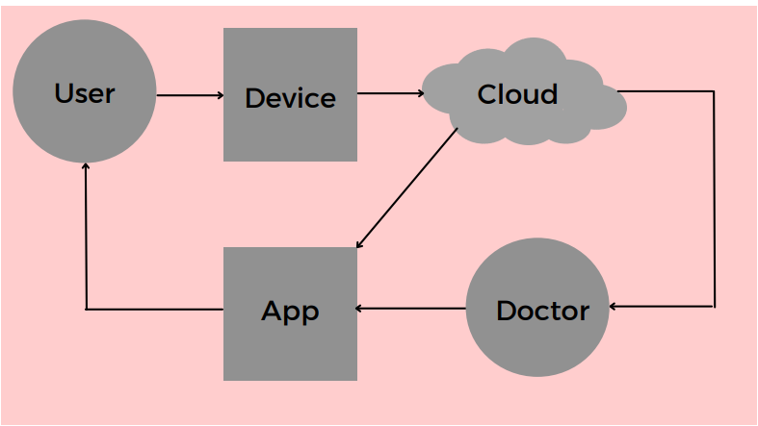
Figure 1 : Remote Health Monitoring and Analyzing system
The objective of our work is to
• Create a remote health monitoring system primarily using IOT in an affordable range, the data from which gets collected and stored in our database.
• Further we look forward to analyze this data in respect to standard medical guidelines and also with an aid of expert suggestion from medical consultants.
• The reviewed analysis gets displayed to the user using a web application interface and the user gets further notification to take precautionary steps and look after his/her health.
To promote health awareness lacking in the current Indian scenario. The central idea of the paper is to device a daily usable, cost effective, portable health monitoring and analyzing model .
Hence this idea is being engineered to focus on collecting real life sensed data and analyzing a real life solution to access real time health data and its associated analysis to foster awareness and connect to medical help as per requirement of the user. Communication with the doctor to receive a detailed medical consultation and report has been established through the designed user friendly application at both ends .
Our work has novelty in the context of two versions explained below while compared to other remote health monitoring works[6],[7].

Our Proposed model proposes two versions
- Self Analysis Version (Unpaid Model)
(i) Data is collected from the user using hand device
(ii) Analyzed data is sent to cloud
(iii) User is sending feedback as per the data analyzed by AI

- Professional Version (Paid Model)
(i) Data is collected from the user using hand device
(ii) Analyzed data is sent to cloud
(iii) Data is sent to the medical expert
(iv) User is sending feedback as per the data analyzed by the Doctor .

Focus of the paper is on IOT Implementations, Cloud Networking and Web application development so that with the aid of internet, people from any remote corner of the earth could avail the facility of this device.

Gathering of Sensed data
The sensed data of one's heart rate, oxygen saturation level, temperature and pressure is collected by the following sensors given in table I.
TABLE I: Parameters and Specifications
Parameters | Used Sensors | Accuracy | Range
Temperature  . | DS18B20 | +-0.5 Degree C | -10°C  to 85°C
Heart Rate | MAX30100 | 97.11% and 98.84% | 1.8 to 3.3V
SPO2 | MAX30100 | 97.11% and 98.84% | 80 and 100 millimeters
Pressure | DHT11 | 5% accuracy | -40°C to +125°C

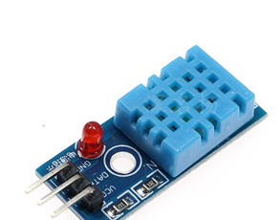
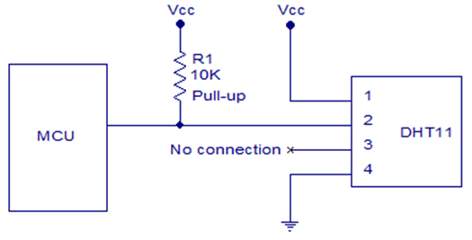
Figure 2 : DHT11 Sensor and its interfacing

Interfacing the sensor with the MCU
The DHT 11 Sensor was thus interfaced with Arduino UNO as shown in figure 2 . The other two sensors MAX30100( for heart rate and SPO2) and DS18b20 is also interfaced
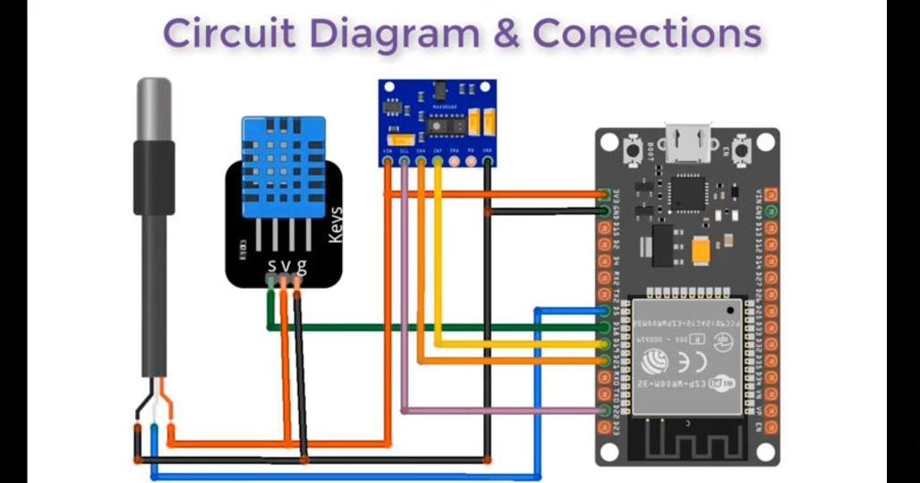

Figure 3a. Layout represenation for Interfacing of sensors with Arduino UNO .

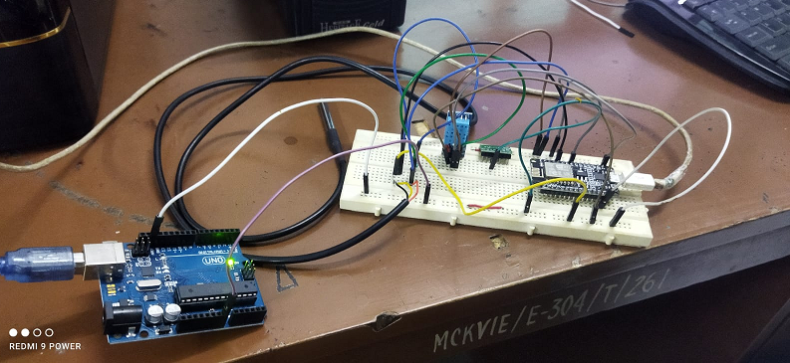

Figure 3b : Interfacing of sensors with Arduino UNO

Interfacing the Application Software with the Cloud
Health monitoring apps help to track all types of activities of users and can set a target to achieve their goal it also measure the previous activity data to current data so that improvement occurs at regular intervals .
The application ( APP) software has been designed with the help of MIT App inventor.The android application has been developed for receiving the medical parameters which is displayed on android mobile with the help of sensors and at a the time uploaded onto the webserver of NodeMCU. After opening the android app in mobile it shows the list of modules as shown figure 4 below .
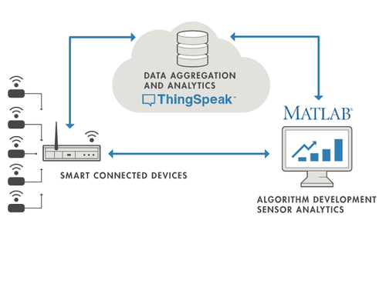

Figure 4 : Think speak Interfacing

RESULTS

Hardware interface output:
The output from all the sensors as mentioned in table I are taken and shown in figure5 .

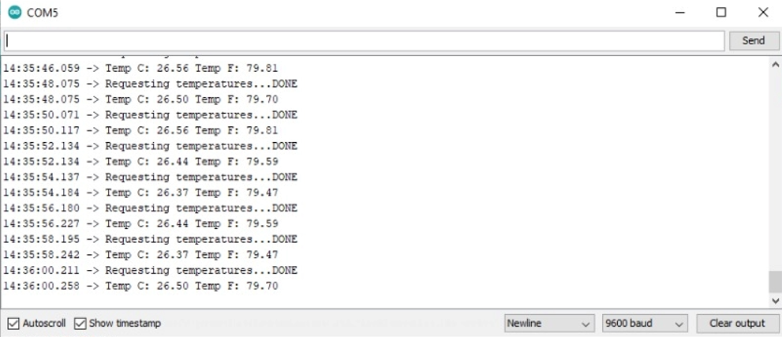
Figure 5 aDS18b20 sensor output

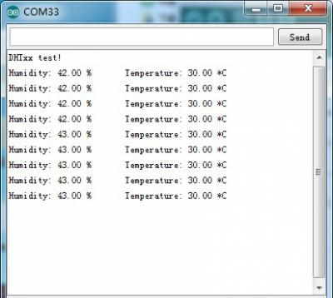

Figure 5b DHT11 sensor output

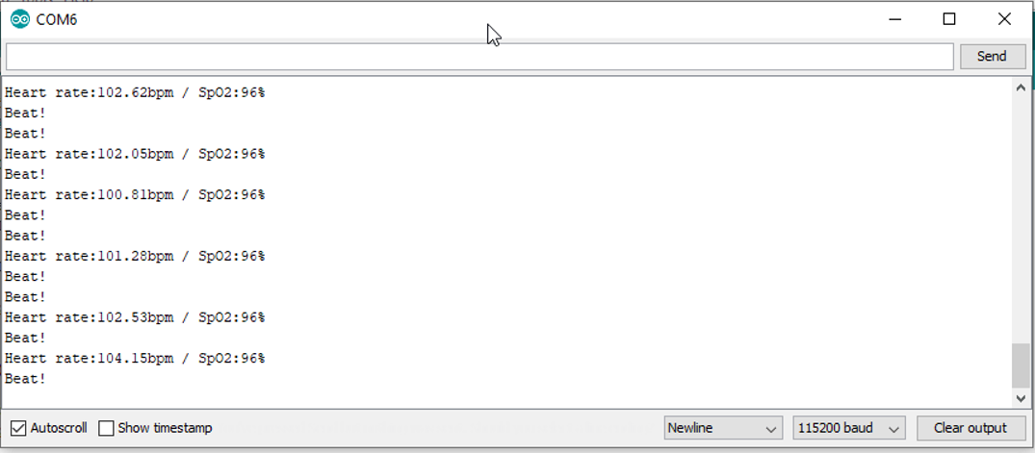
Figure 5 cMAX30100 Sensor output

Application Software output:

The application software has the following modules
(i) Registration: The user has to register into the system with his basic details as shown in figure 6 b .
(ii) Login: The user has to login into the system keeping the data secure figure 6 b .
(iii) Profile: The user can see his profile and can update his physical attributes which also reflects on other things.
(iv) Health Report : The system shows the user about his BMI level, body temperature, pressure, humidity, oxygen rate and status. Users can download their health report and get access to send the data to doctors. Graphical health reports is generated based on date and time for maintaining a day-to-day report as shown in figure 6c
(v) FAQ: This module is based on the queries of our previous users frequently asked questions. Also some safety measure information and surviving critical condition guidelines are available. Users can read those and act accordingly.
(vi) Contact Us:
If the user faces any difficulty while using this app can also interact with service provider via our real-time mail services. There will be a form where users share their issues with us. as shown in Figure 6d
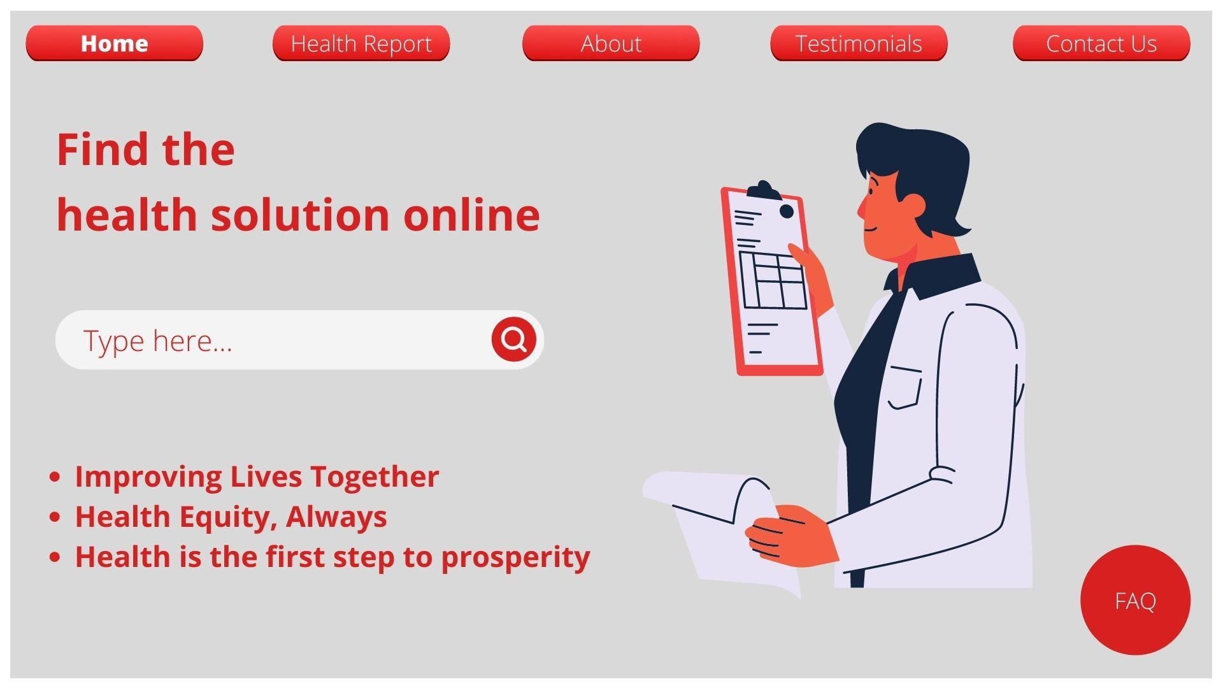
Figure 6 a : Cover page of the Application
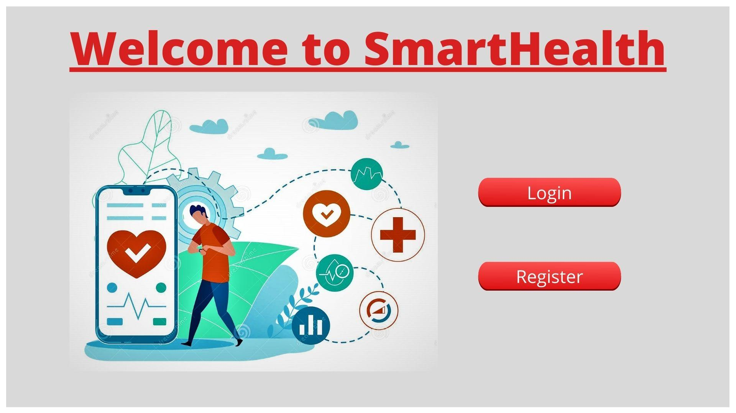

Figure 6b Home Page with login and registerartion button.

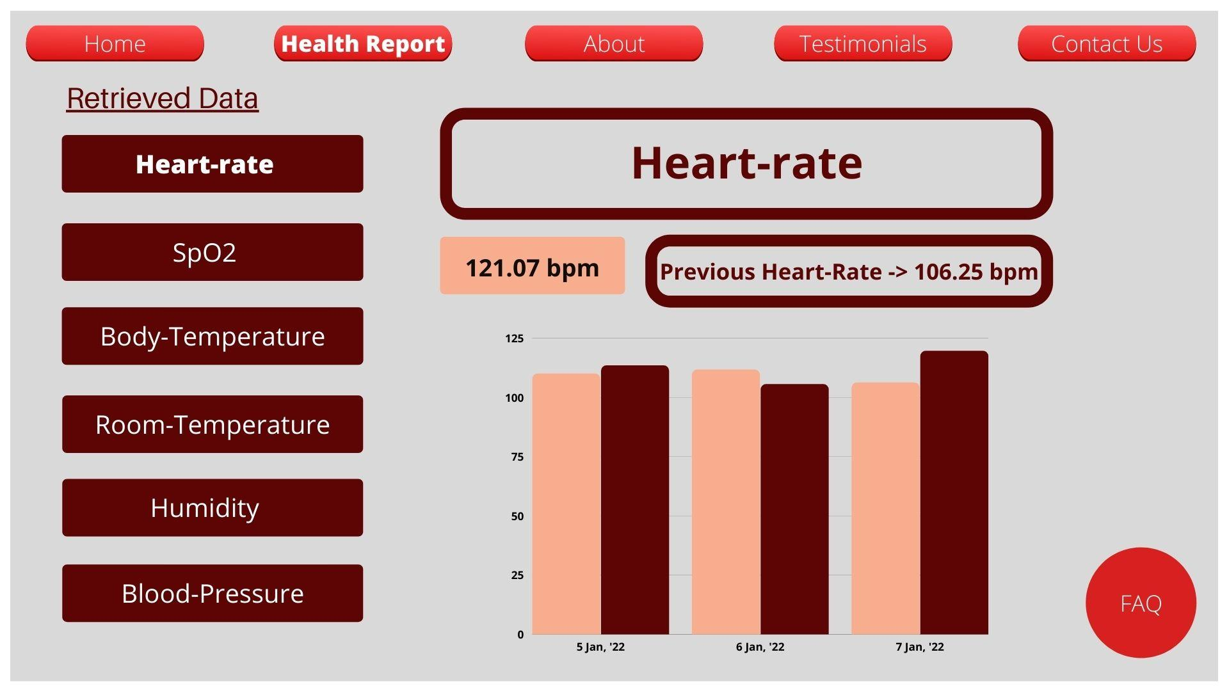
Figure 6c The self analyzed Health Report
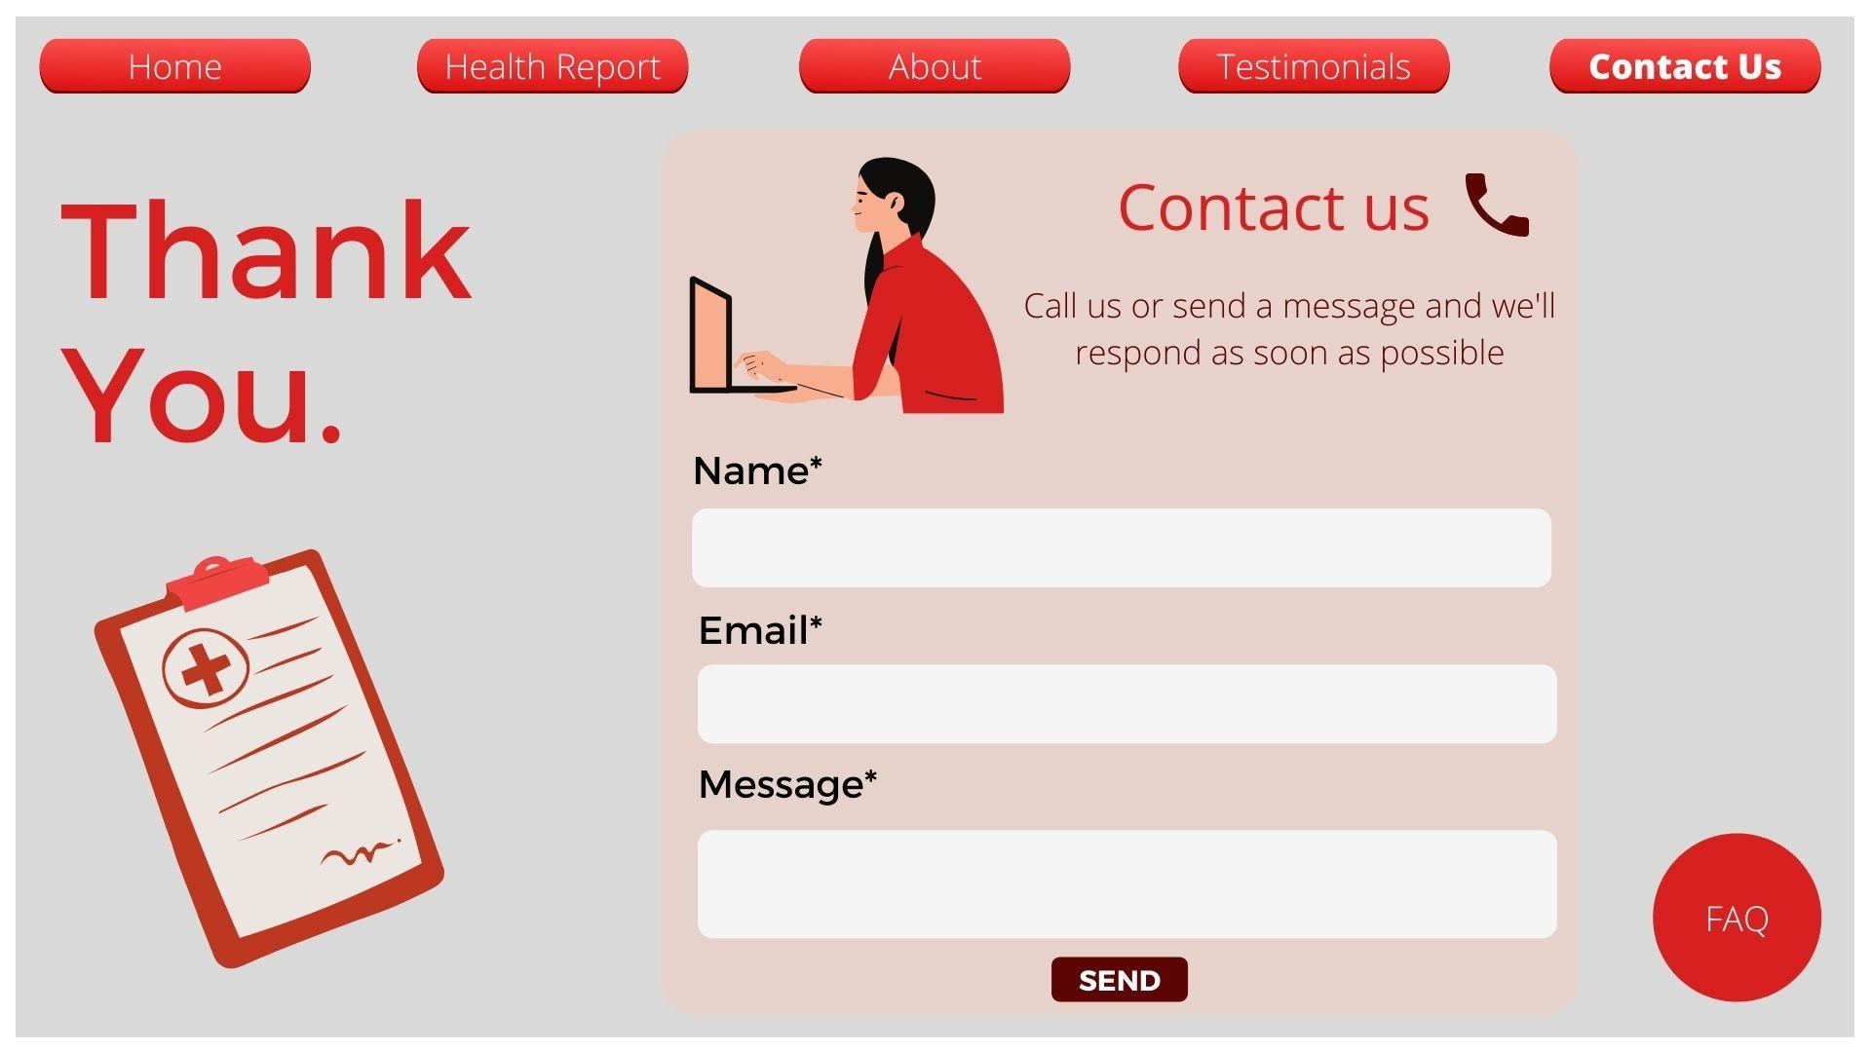
Figure 6d : The Contact Page of service provider
The doctors diagonosis from the above health report is given in Table II:

Table II: Doctor's Diagonosis

Sl No: | Parameters | Diagonosis forNormal Patients | Diagonosis forDiabetic Patients
1 | Temparature | Outputs fromthinkspeak & matlab | Outputs fromthinkspeak & matlab
2 | Heart Rate | Outputs fromthinkspeak & matlab | Outputs fromthinkspeak & matlab
3 | SPO2 | Outputs fromthinkspeak & matlab | Outputs fromthinkspeak & matlab
4 | Pressure | Outputs fromthinkspeak & matlab | Outputs fromthinkspeak & matlab

CONCLUSION
Wearable devices help healthcare professionals and patients to deal with various health issues at a reduced cost. These devices are noninvasive and can be developed by integrating various sensors with wearable accessories used by humans such as watch, wristband , necklace, shirt, shoes, handbag, caps, and so on .These devices are lightweight and so compact that people tend to use these devices much more in the years to come. The devices become the future of the upcoming generations. The devices can perform every task for easing the life of the people.
The sensor attached is used to collect the environmental and patient’s health information. This information is then uploaded to the server/databases. Smart watches have wearable technology, with digital power, displaying heartbeat, blood pressure, and calories burned. The interconnectivity of these wearable devices with a mobile application enhances the computational power of the device. The application can be further used for easy processing and visualization of the collected information.

References
- IVlacheas, P., Giaffreda, R., Stavroulaki, V., Kelaidonis, D., Foteinos, V.,Poulios, G., & Moessner, K. (2013), Enabling smart cities through a cognitive management framework for the internet of things, Communications Magazine, IEEE, 51(6), 102-111.
[2] Sasidharan, S., Somov, A., Biswas, A. R., & Giaffreda, R. (2014,
March), Cognitive management framework for Internet of Things:A
prototype implementation, InInternet of Things (WF-IoT), 2014 IEEE
World Forum on(pp. 538-543). IEEE.
[3] Thilakanathan, D., Chen, S., Nepal, S., Calvo, R., & Alem, L. (2014), A platform for secure monitoring and sharing of generic health data in the Cloud, Future Generation Computer Systems, 35, 102-113.
[4] Giniat, E. J. (2011), Cloud computing: innovating the business of health care, Healthcare financial management: journal of the Healthcare Financial Management Association, 65(5), 130-131.
[5] Jassas, M. S., Qasem, A. A., & Mahmoud, Q. H. (2015, May), A smartsystem connecting e-health sensors and the cloud, In Electrical
and Computer Engineering (CCECE), 2015 IEEE 28th Canadian Conference on (pp. 712-716). IEEE.
[6] Ayush Bansal, Sunil Kumar, Anurag Bajpai, Vijay N. Tiwari, Mithun Nayak, Shankar Venkatesan and Rangavittal Narayanan, Remote health monitoring system for detecting cardiac disorders, Special Issue: Computational Models and Methods in Systems Biology and Medicine, IET Syst. Biol., 2015, Vol. 9, Iss. 6, pp. 309–314.
[7] Ananda Mohon Ghosh, Debashish Halder, SK Alamgir Hossain, Remote Health Monitoring System through IoT, 5t^{h} International Conference on Informatics, Electronics and Vision (ICIEV) IEEE , 2016, pp .921-926.

.

.

